First Mittagong Community Bank

New Perspectives Excel 2019 | Module 2: End of Module Project 1



Formatting Workbook Text and Data

# GETTING STARTED

* Open the file **NP_EX19_EOM2-1_*FirstLastName*_1.xlsx**, available for download from the SAM website.
* Save the file as **NP_EX19_EOM2-1_*FirstLastName*_2.xlsx** by changing the “1” to a “2”.

If you do not see the **.xlsx** file extension in the Save As dialog box, do not type it. The program will add the file extension for you automatically.

* With the file **NP_EX19_EOM2-1_*FirstLastName*_2.xlsx** still open, ensure that your first and last name is displayed in cell B6 of the Documentation sheet.

If cell B6 does not display your name, delete the file and download a new copy from the SAM website.

* PROJECT STEPS

1. Titus Allison is a loan officer with First Mittagong Community Bank. Titus is adding formatting to the workbook he uses to track interest rates to increase its usability.  
   Change the theme of the workbook to **Office**.
2. Switch to the *Mortgage* worksheet, then format the headings. Merge and center the range A1:D1. Apply the FM Heading cell style to the merged cell.
3. Merge and center the range A2:D2. Apply the FM Subheadingcell style to the merged cell.
4. Format the effective date information. For the range A4:B4, apply the Note cell style. For cell A4, apply italic to the text and align right. For cell B4, change the date format to day-month-year (e.g., 21-Nov-21).
5. Format the mortgage rate table. For the headings in A6:D6, center and bold the text, then change the font color to Blue-Gray, Text 2 (4th column, 1st row of the Theme Colors palette). Merge and center the range A7:A9.
6. Copy the formatting of the merged cell in the range A7:A9, then paste the formatting in the range A10:A18 to create three more merged cells.
7. In the range B7:B18, apply the Percentage number format with two decimal places, then copy this format to the range D7:D18.
8. In the range C7:C18, apply the Number number format, then increase the decimals to show three decimal places.
9. Change the background color of the range A7:D9 to Green, Accent 6, Lighter 80% (10th column, 2nd row of the Theme Colors palette).
10. Copy the formatting of the range A7:D9, then paste the formatting in the range A13:D15.
11. In the range A6:D18, add a border around all cells using the All Borders option.
12. Switch to the *Money Market* worksheet. For the range A1:D1, merge and center the contents and apply the custom cell style FM Heading. For the range A2:D2, merge and center the contents and apply the custom style FM Subheading.
13. Copy the content and formatting from the range A4:B4 in the *Mortgage* worksheet, then paste them on the range A4:B4 in the *Money Market* worksheet.
14. To format the money market rate table, for the range B7:B11, apply the Currency number format with two decimal places, then repeat for the range C7:C10. For the range D7:D11, apply the Percentage number format with two decimal places.
15. Change the tab color of the *Mortgage* worksheet to Purple (10th column of the Standard Colors palette). Change the tab color of the *Money Market* worksheet to Dark Red (1st column of the Standard Colors palette).

Your workbook should look like the Final Figures on the following pages. Save your changes, close the workbook, and then exit Excel. Follow the directions on the SAM website to submit your completed project.

* Final Figure 1: Mortgage Worksheet

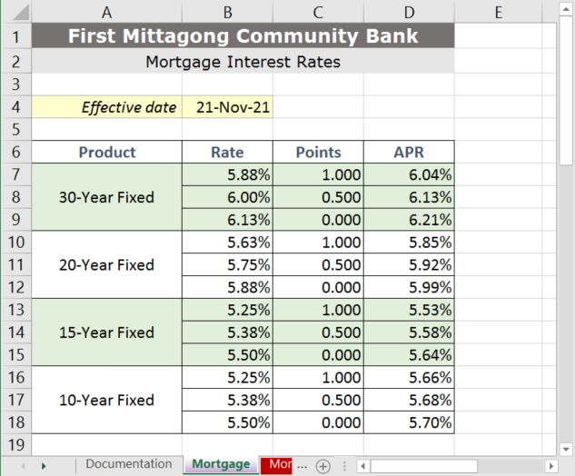

* Final Figure 2: Money Market Worksheet

